# Imperial Hotel

**III SEMESTER**



Name Visu Yadav

Reg No 189301207

Section D

Department of Computer Science and Engineering

SCHOOL OF COMPUTING AND INFORMATION TECHNOLOGY MANIPAL UNIVERSITY JAIPUR

2019-20

Table of Contents

**PROJECT SYNOPSIS**

**Currently Working On**

**Software Requirments**

**MySQL   Code**

**JAVA Code**

PROJECT SYNOPSIS

During the past several decades personnel function has been transformed from a relatively obscure record keeping staff to central and top level management function. There are many factors that have influenced this transformation like technological advances, professionalism, and general recognition of human beings as most important resources.

A computer based management system is designed to handle all the primary information required to calculate monthly statements. Separate database is maintained to handle all the details required for the correct statement calculation and generation.

This project intends to introduce more user friendliness in the various activities such as record up dation, maintenance, and searching.

The searching of record has been made quite simple as all the details of the customer can be obtained by simply keying in the identification of that customer.

Similarly, record maintenance and up dation can also be accomplished by using the identification of the customer with all the details being automatically generated. These details are also being promptly automatically updated in the master file thus keeping the record absolutely up-to-date.

The entire information has maintained in the database or Files and whoever wants to retrieve can’t retrieve, only authorization user can retrieve the necessary information which can be easily be accessible from the file.

**Currently Working On**

I am currently working on a property dealing app that will allow property dealers to upload and keep up to date the various property available around the cities that can be rented or bought by the customers. I using android studio for this app and the languages are java and sql with firebase.

**The Software Requiremnts**

Netbeans (version 8 and above)

Mysql

**MYSQL**

mysql> create database imperial_hotel;

Query OK, 1 row affected (0.28 sec)

mysql> use imperial_hotel;

Database changed

mysql> create table Test(Date date, RoomType varchar(100), Rooms int(2),Adults int(2),Children int(2));

Query OK, 0 rows affected (2.39 sec)

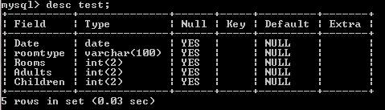

mysql> create table roomprice(RoomType varchar(100), Price decimal(10));

Query OK, 0 rows affected (0.45 sec)

mysql> insert into roomprice values("CLUB ONE-BEDROOM SUITE",10000);

mysql> insert into roomprice values("DELUXE ONE-BEDROOM SUITE",15000);

mysql> insert into roomprice values("DELUXE TWIN ONE-BEDROOM SUITE",17000);

mysql> insert into roomprice values("DELUXE TWO-BEDROOM SUITE",25000);

mysql> insert into roomprice values("DIPLOMATIC THREE-BEDROOM SUITE",50000);

mysql> insert into roomprice values("PANORAMIC ONE-BEDROOM SUITE",27000);

mysql> insert into roomprice values("PRESIDENTIAL TWO-BEDROOM SUITE",60000);

mysql> insert into roomprice values("ROYAL TWO-BEDROOM SUITE",100000);

Query OK, 0 rows affected (0.45 sec)

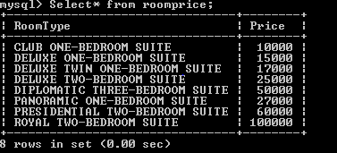

mysql> create table login(username varchar(20) primary key,email varchar(50),mobile varchar(10),password varchar(20),code varchar(20));

Query OK, 0 rows affected (0.44 sec)

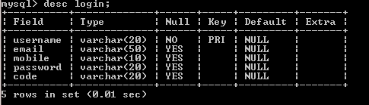

mysql> create table booking(SNO int(8),username varchar(100),Noperson int(2),BookingNo int(8),RoomNo int(3),ChargesDay decimal(10,2),Advance decimal(10.2),Total decimal(10,2));

Query OK, 0 rows affected (0.40 sec)

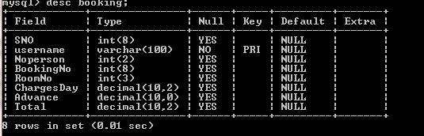

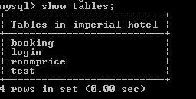

**NETBEANS**



public Home() {

initComponents();

jLabel4.setIcon(new javax.swing.ImageIcon(getClass().getResource("/Images/homewallpaper.jpg")));

jLabel1.setIcon(new javax.swing.ImageIcon(getClass().getResource("/Images/logo.gif")));

}

private void jLabel3FocusGained(java.awt.event.FocusEvent evt) {

}

private void jButton4ActionPerformed(java.awt.event.ActionEvent evt) {

Accommodations a = new Accommodations();

a.setVisible(true);

this.setVisible(false);

}

private void jButton1ActionPerformed(java.awt.event.ActionEvent evt) {

RoomOverview a = new RoomOverview();

a.setVisible(true);

this.setVisible(false); // TODO add your handling code here:

}

private void jButton2ActionPerformed(java.awt.event.ActionEvent evt) {

Login a = new Login();

a.setVisible(true);

this.setVisible(false);

}

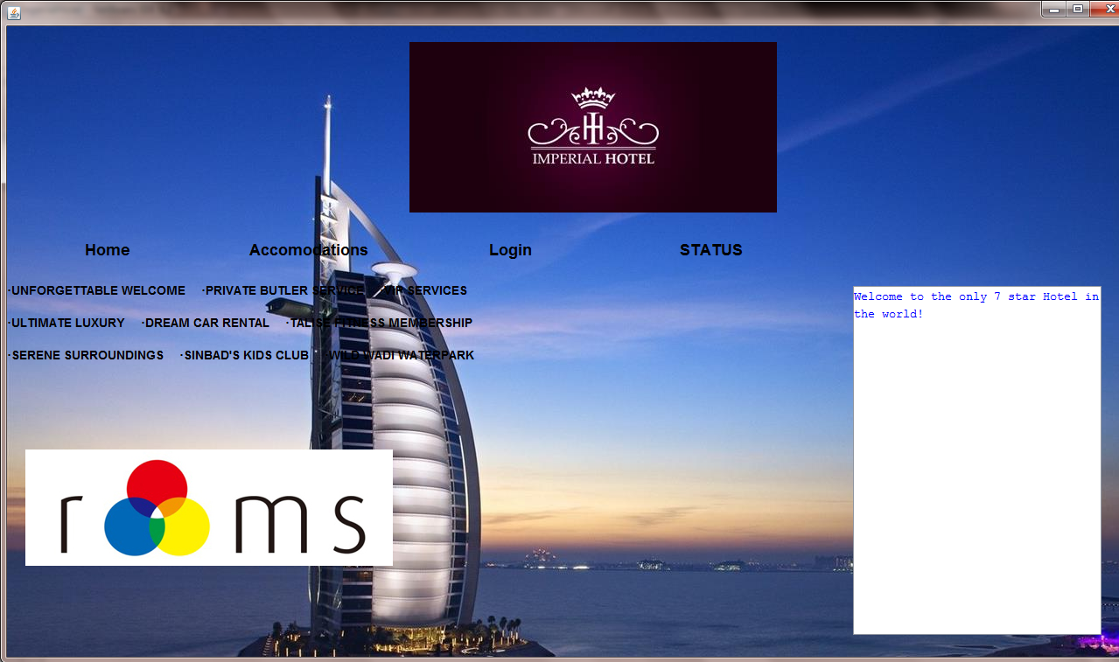

public RoomOverview() {

initComponents();

jLabel4.setIcon(new javax.swing.ImageIcon(getClass().getResource("/Images/wallpaper.jpg")));

jLabel1.setIcon(new javax.swing.ImageIcon(getClass().getResource("/Images/logonew.jpg")));

jLabel11.setIcon(new javax.swing.ImageIcon(getClass().getResource("/Images/rooms.jpg")));

jTextArea1.setText("Welcome to the only 7 star Hotel in the world!");

}private void jButton1ActionPerformed(java.awt.event.ActionEvent evt) {

Accommodations a = new Accommodations();

a.setVisible(true);

this.setVisible(false);

}

private void jButton4ActionPerformed(java.awt.event.ActionEvent evt) {

Home a = new Home();

a.setVisible(true);

this.setVisible(false);

}

private void jButton2ActionPerformed(java.awt.event.ActionEvent evt) {

Login a = new Login();

a.setVisible(true);

this.setVisible(false);

}

private void jButton3ActionPerformed(java.awt.event.ActionEvent evt) {

// TODO add your handling code here:

}

private void jLabel3MouseMoved(java.awt.event.MouseEvent evt) {

jTextArea1.setText("Visitors can arrive by helicopter to experience a breathtaking \n birds-eye-view of the city.");

jLabel11.setIcon(new javax.swing.ImageIcon(getClass().getResource("/Images/d.jpg")));

jLabel11.setText("");

}

private void jLabel6MouseMoved(java.awt.event.MouseEvent evt) {

jTextArea1.setText("There are over 1,600 colleagues working in Burj Al Arab, \n which makes the staff-to-suite ratio 8:1.");

jLabel11.setIcon(new javax.swing.ImageIcon(getClass().getResource("/Images/2.jpg")));

jLabel11.setText("");

}

private void jLabel5MouseMoved(java.awt.event.MouseEvent evt) {

jTextArea1.setText("Experience ultimate luxury from the moment you arrive at Burj Al Arab.");

jLabel11.setIcon(new javax.swing.ImageIcon(getClass().getResource("/Images/4.jpg")));

jLabel11.setText("");

}

private void jLabel10MouseMoved(java.awt.event.MouseEvent evt) {

jTextArea1.setText("See the Burj Al Arab iconic sail shape from the Arabian Gulf with a private yacht \ncharter service available exclusively to our guests. Offering the\n height of indulgence, you and your guests will enjoy\n total privacy, and the services of our skilled, attentive onboard team \n(comprising a butler, hostess and chef). For added relaxation, a spa therapist \ncan also join you on board to provide luxury pampering treatments.");

jLabel11.setIcon(new javax.swing.ImageIcon(getClass().getResource("/Images/12.jpg")));

jLabel11.setText("");

}

private void jLabel7MouseMoved(java.awt.event.MouseEvent evt) {

jTextArea1.setText("Take in life from the fast lane. Our fleet of luxury cars is\n available for private hire, and offers unsurpassed auto-mobiles. Glide \nthe streets of Dubai in the world's most exclusive cars, including models\n from Aston Martin, Ferrari and Lamborghini. For a touch of\n old world glamour, classic cars tempt with an understated elegance\n that even today is rarely matched.");

jLabel11.setIcon(new javax.swing.ImageIcon(getClass().getResource("/Images/5.jpg")));

jLabel11.setText("");

}

private void jLabel12MouseMoved(java.awt.event.MouseEvent evt) {

jTextArea1.setText("The Sinbad's Kids Club is located on the 18th floor of Burj Al Arab, adjacent to\n the Diwania Library and is staffed at all times by professional carers. \nThe service is offered exclusive to in-house guests and Spa Members on a\n complimentary basis and caters for children aged between 1–12 years of age");

jLabel11.setIcon(new javax.swing.ImageIcon(getClass().getResource("/Images/13.jpg")));

jLabel11.setText("");

}

private void jLabel9MouseMoved(java.awt.event.MouseEvent evt) {

jTextArea1.setText("Talise Fitness is much more than a club but a gateway \nto the most exclusive and prestigious luxury hotel in Dubai.");

jLabel11.setIcon(new javax.swing.ImageIcon(getClass().getResource("/Images/10.jpg")));

jLabel11.setText("");

}

private void jLabel13MouseMoved(java.awt.event.MouseEvent evt) {

jTextArea1.setText("Burj Al Arab guests can enjoy unlimited access to Wild Wadi Waterpark \nwhich is accessible via a complimentary buggy drive or short walk.");

jLabel11.setIcon(new javax.swing.ImageIcon(getClass().getResource("/Images/14.jpg")));

jLabel11.setText("");

}

private void jLabel8MouseMoved(java.awt.event.MouseEvent evt) {

jTextArea1.setText("VIP service is about more than a mere luxury.\n It's about creating once in a lifetime opportunities.");

jLabel11.setIcon(new javax.swing.ImageIcon(getClass().getResource("/Images/3.jpg")));

jLabel11.setText("");

}

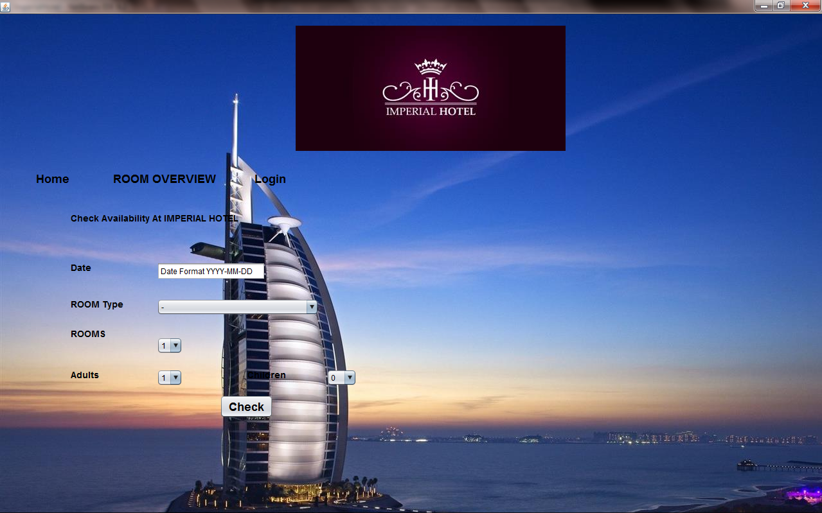

package imperialhotel;

import java.sql.DriverManager;

import java.sql.ResultSet;

import javax.swing.JOptionPane;

/**

*

* @author student

*/

public class Accommodations extends javax.swing.JFrame {

/**

* Creates new form Accommodations

*/

public Accommodations() {

initComponents();

jLabel8.setIcon(new javax.swing.ImageIcon(getClass().getResource("/Images/wallpaper.jpg")));

jLabel1.setIcon(new javax.swing.ImageIcon(getClass().getResource("/Images/logonew.jpg")));

jLabel11.setIcon(new javax.swing.ImageIcon(getClass().getResource("/Images/rooms.jpg")));

}

/**

* This method is called from within the constructor to initialize the form.

* WARNING: Do NOT modify this code. The content of this method is always

* regenerated by the Form Editor.

*/

@SuppressWarnings("unchecked")

// <editor-fold defaultstate="collapsed" desc="Generated Code">

private void initComponents() {

jLabel1 = new javax.swing.JLabel();

jLabel2 = new javax.swing.JLabel();

jLabel3 = new javax.swing.JLabel();

q = new javax.swing.JTextField();

jLabel4 = new javax.swing.JLabel();

a = new javax.swing.JComboBox<>();

jLabel7 = new javax.swing.JLabel();

w = new javax.swing.JComboBox<>();

jLabel5 = new javax.swing.JLabel();

e = new javax.swing.JComboBox<>();

jButton5 = new javax.swing.JButton();

jLabel6 = new javax.swing.JLabel();

r = new javax.swing.JComboBox<>();

jLabel11 = new javax.swing.JLabel();

jPanel1 = new javax.swing.JPanel();

jButton4 = new javax.swing.JButton();

jButton1 = new javax.swing.JButton();

jButton2 = new javax.swing.JButton();

jLabel8 = new javax.swing.JLabel();

setDefaultCloseOperation(javax.swing.WindowConstants.EXIT_ON_CLOSE);

getContentPane().setLayout(new org.netbeans.lib.awtextra.AbsoluteLayout());

jLabel1.setHorizontalAlignment(javax.swing.SwingConstants.CENTER);

jLabel1.setIcon(new javax.swing.ImageIcon(getClass().getResource("/images/logonew.jpg"))); // NOI18N

getContentPane().add(jLabel1, new org.netbeans.lib.awtextra.AbsoluteConstraints(460, 10, 420, 210));

jLabel2.setFont(new java.awt.Font("Dialog", 1, 14)); // NOI18N

jLabel2.setText("Check Availability At IMPERIAL HOTEL");

getContentPane().add(jLabel2, new org.netbeans.lib.awtextra.AbsoluteConstraints(110, 308, -1, -1));

jLabel3.setFont(new java.awt.Font("Dialog", 1, 14)); // NOI18N

jLabel3.setText("Date");

getContentPane().add(jLabel3, new org.netbeans.lib.awtextra.AbsoluteConstraints(110, 385, -1, -1));

q.setText("Date Format YYYY-MM-DD");

q.addMouseListener(new java.awt.event.MouseAdapter() {

public void mouseClicked(java.awt.event.MouseEvent evt) {

qMouseClicked(evt);

}

});

q.addActionListener(new java.awt.event.ActionListener() {

public void actionPerformed(java.awt.event.ActionEvent evt) {

qActionPerformed(evt);

}

});

q.addKeyListener(new java.awt.event.KeyAdapter() {

public void keyReleased(java.awt.event.KeyEvent evt) {

qKeyReleased(evt);

}

public void keyTyped(java.awt.event.KeyEvent evt) {

qKeyTyped(evt);

}

});

getContentPane().add(q, new org.netbeans.lib.awtextra.AbsoluteConstraints(244, 386, 169, -1));

jLabel4.setFont(new java.awt.Font("Dialog", 1, 14)); // NOI18N

jLabel4.setText("ROOM Type");

getContentPane().add(jLabel4, new org.netbeans.lib.awtextra.AbsoluteConstraints(110, 434, -1, -1));

a.setModel(new javax.swing.DefaultComboBoxModel<>(new String[] { "-", "CLUB ONE-BEDROOM SUITE", "DELUXE ONE-BEDROOM SUITE", "DELUXE TWIN ONE-BEDROOM SUITE", "DELUXE TWO-BEDROOM SUITE", "DIPLOMATIC THREE-BEDROOM SUITE", "PANORAMIC ONE-BEDROOM SUITE", "PRESIDENTIAL TWO-BEDROOM SUITE", "ROYAL TWO-BEDROOM SUITE", " ", " ", " " }));

a.addActionListener(new java.awt.event.ActionListener() {

public void actionPerformed(java.awt.event.ActionEvent evt) {

aActionPerformed(evt);

}

});

getContentPane().add(a, new org.netbeans.lib.awtextra.AbsoluteConstraints(244, 435, -1, -1));

jLabel7.setFont(new java.awt.Font("Dialog", 1, 14)); // NOI18N

jLabel7.setText("ROOMS");

getContentPane().add(jLabel7, new org.netbeans.lib.awtextra.AbsoluteConstraints(110, 488, -1, -1));

w.setModel(new javax.swing.DefaultComboBoxModel<>(new String[] { "1", "2", "3", "4" }));

w.addActionListener(new java.awt.event.ActionListener() {

public void actionPerformed(java.awt.event.ActionEvent evt) {

wActionPerformed(evt);

}

});

getContentPane().add(w, new org.netbeans.lib.awtextra.AbsoluteConstraints(244, 489, 40, -1));

jLabel5.setFont(new java.awt.Font("Dialog", 1, 14)); // NOI18N

jLabel5.setText("Adults");

getContentPane().add(jLabel5, new org.netbeans.lib.awtextra.AbsoluteConstraints(110, 532, -1, -1));

e.setModel(new javax.swing.DefaultComboBoxModel<>(new String[] { "1", "2", "3", "4", "5", "6", "7", "8", "9", "10" }));

getContentPane().add(e, new org.netbeans.lib.awtextra.AbsoluteConstraints(244, 533, 40, -1));

jButton5.setFont(new java.awt.Font("Dialog", 1, 18)); // NOI18N

jButton5.setText("Check");

jButton5.addActionListener(new java.awt.event.ActionListener() {

public void actionPerformed(java.awt.event.ActionEvent evt) {

jButton5ActionPerformed(evt);

}

});

getContentPane().add(jButton5, new org.netbeans.lib.awtextra.AbsoluteConstraints(342, 593, -1, -1));

jLabel6.setFont(new java.awt.Font("Dialog", 1, 14)); // NOI18N

jLabel6.setText("Children");

getContentPane().add(jLabel6, new org.netbeans.lib.awtextra.AbsoluteConstraints(385, 532, -1, -1));

r.setModel(new javax.swing.DefaultComboBoxModel<>(new String[] { "0", "1", "2", "3", "4", "5", "6", "7", "8", "9", "10" }));

getContentPane().add(r, new org.netbeans.lib.awtextra.AbsoluteConstraints(508, 533, -1, -1));

jLabel11.setIcon(new javax.swing.ImageIcon(getClass().getResource("/images/rooms.jpg"))); // NOI18N

getContentPane().add(jLabel11, new org.netbeans.lib.awtextra.AbsoluteConstraints(600, 310, 773, 422));

jPanel1.setOpaque(false);

jPanel1.setLayout(null);

jButton4.setFont(new java.awt.Font("Dialog", 1, 18)); // NOI18N

jButton4.setText("Home");

jButton4.setContentAreaFilled(false);

jButton4.setRequestFocusEnabled(false);

jButton4.addActionListener(new java.awt.event.ActionListener() {

public void actionPerformed(java.awt.event.ActionEvent evt) {

jButton4ActionPerformed(evt);

}

});

jPanel1.add(jButton4);

jButton4.setBounds(40, 0, 85, 33);

jButton1.setFont(new java.awt.Font("Dialog", 1, 18)); // NOI18N

jButton1.setText("ROOM OVERVIEW");

jButton1.setContentAreaFilled(false);

jButton1.setMaximumSize(new java.awt.Dimension(195, 33));

jButton1.setMinimumSize(new java.awt.Dimension(195, 33));

jButton1.addActionListener(new java.awt.event.ActionListener() {

public void actionPerformed(java.awt.event.ActionEvent evt) {

jButton1ActionPerformed(evt);

}

});

jPanel1.add(jButton1);

jButton1.setBounds(160, 0, 193, 33);

jButton2.setFont(new java.awt.Font("Dialog", 1, 18)); // NOI18N

jButton2.setText("Login");

jButton2.setContentAreaFilled(false);

jButton2.setMaximumSize(new java.awt.Dimension(195, 33));

jButton2.setMinimumSize(new java.awt.Dimension(195, 33));

jButton2.addActionListener(new java.awt.event.ActionListener() {

public void actionPerformed(java.awt.event.ActionEvent evt) {

jButton2ActionPerformed(evt);

}

});

jPanel1.add(jButton2);

jButton2.setBounds(380, 0, 81, 33);

getContentPane().add(jPanel1, new org.netbeans.lib.awtextra.AbsoluteConstraints(0, 240, 720, 40));

jLabel8.setIcon(new javax.swing.ImageIcon(getClass().getResource("/images/Wallpaper.jpg"))); // NOI18N

jLabel8.addMouseMotionListener(new java.awt.event.MouseMotionAdapter() {

public void mouseMoved(java.awt.event.MouseEvent evt) {

jLabel8MouseMoved(evt);

}

});

getContentPane().add(jLabel8, new org.netbeans.lib.awtextra.AbsoluteConstraints(0, 0, -1, -1));

pack();

}// </editor-fold>

private void qActionPerformed(java.awt.event.ActionEvent evt) {

// TODO add your handling code here:

}

private void aActionPerformed(java.awt.event.ActionEvent evt) {

if(a.getSelectedItem().equals("-"))

{

jLabel11.setIcon(new javax.swing.ImageIcon(getClass().getResource("/Images/rooms.jpg")));

jLabel11.setText("");

}

if(a.getSelectedItem().equals("CLUB ONE-BEDROOM SUITE"))

{

jLabel11.setIcon(new javax.swing.ImageIcon(getClass().getResource("/Images/a.jpg")));

jLabel11.setText("");

}

if(a.getSelectedItem().equals("DELUXE ONE-BEDROOM SUITE"))

{

jLabel11.setIcon(new javax.swing.ImageIcon(getClass().getResource("/Images/rsz_deluxe_one-bedroom_suite.jpg")));

jLabel11.setText("");

}

if(a.getSelectedItem().equals("DELUXE TWIN ONE-BEDROOM SUITE"))

{

jLabel11.setIcon(new javax.swing.ImageIcon(getClass().getResource("/Images/rsz_deluxe_twin_one-bedroom_suite1.jpg")));

jLabel11.setText("");

}

if(a.getSelectedItem().equals("DELUXE TWO-BEDROOM SUITE"))

{

jLabel11.setIcon(new javax.swing.ImageIcon(getClass().getResource("/Images/DELUXE TWO-BEDROOM SUITE1.jpg")));

jLabel11.setText("");

}

if(a.getSelectedItem().equals("DIPLOMATIC THREE-BEDROOM SUITE"))

{

jLabel11.setIcon(new javax.swing.ImageIcon(getClass().getResource("/Images/rsz_diplomatic_three-bedroom_suite.jpg")));

jLabel11.setText("");

}

if(a.getSelectedItem().equals("PANORAMIC ONE-BEDROOM SUITE"))

{

jLabel11.setIcon(new javax.swing.ImageIcon(getClass().getResource("/Images/rsz_panoramic_one-bedroom_suite.jpg")));

jLabel11.setText("");

}

if(a.getSelectedItem().equals("PRESIDENTIAL TWO-BEDROOM SUITE"))

{

jLabel11.setIcon(new javax.swing.ImageIcon(getClass().getResource("/Images/rsz_presidential_two-bedroom_suite.jpg")));

jLabel11.setText("");

}

if(a.getSelectedItem().equals("ROYAL TWO-BEDROOM SUITE"))

{

jLabel11.setIcon(new javax.swing.ImageIcon(getClass().getResource("/Images/ROYAL TWO-BEDROOM SUITE.jpg")));

jLabel11.setText("");

}

}

private void wActionPerformed(java.awt.event.ActionEvent evt) {

// TODO add your handling code here:

}

private void jButton5ActionPerformed(java.awt.event.ActionEvent evt) {

String date =q.getText();

String roomtype= a.getSelectedItem().toString();

int rooms = Integer.parseInt(w.getSelectedItem().toString());

int adults = Integer.parseInt(e.getSelectedItem().toString());

int children = Integer.parseInt(r.getSelectedItem().toString());

try {

Class.forName("java.sql.DriverManager");

java.sql.Connection con = (java.sql.Connection)

DriverManager.getConnection

("jdbc:mysql://localhost:3306/imperial_hotel","root", "seal1234");

java.sql.Statement stmt = (java.sql.Statement) con.createStatement();

String query="INSERT INTO Test VALUES('"+date+"','"+roomtype+"','"+rooms+"','"+adults+"','"+children+"');";

stmt.executeUpdate(query);

}

catch(Exception e)

//this block is executed in case of an exception

{

//Display an error message in the dialog box for an exception

JOptionPane.showMessageDialog (this, e.getMessage());

}

int pricefinal = 0;

try

{

Class.forName("java.sql.DriverManager");

java.sql.Connection con = (java.sql.Connection)

DriverManager.getConnection

("jdbc:mysql://localhost:3306/imperial_hotel","root", "seal1234");

java.sql.Statement stmt = (java.sql.Statement) con.createStatement();

String query="SELECT price FROM roomprice WHERE roomtype='"+roomtype+"' ;";

ResultSet rs=stmt.executeQuery(query);

if (rs.next())

{

int price = rs.getInt("price");

pricefinal=price;

}

// This part is executed if no matching record is found

else

JOptionPane.showMessageDialog

(this,"Sorry! Room Not Avialabe");

}

catch (Exception e)

{

JOptionPane.showMessageDialog(this, e.getMessage());

}

int dialogButton = JOptionPane.YES_NO_OPTION;

int dialogResult = JOptionPane.showConfirmDialog(this, "This is the price of the room avialabe"+ pricefinal +" Would you like to proceed", "Title on Box", dialogButton);

if(dialogResult == 0) {

//if yes then proceed to login and payment

Login a = new Login(date,rooms,pricefinal);

a.setVisible(true);

this.setVisible(false);

}

else {

}

}

private void qKeyReleased(java.awt.event.KeyEvent evt) {

// TODO add your handling code here:

}

private void qKeyTyped(java.awt.event.KeyEvent evt) {

if(q.getText().length()==4 )

{

q.setText(q.getText()+"-");

}

if(q.getText().length()==7)

{

q.setText(q.getText()+"-");

}

}

private void qMouseClicked(java.awt.event.MouseEvent evt) {

q.setText("");

}

private void jButton4ActionPerformed(java.awt.event.ActionEvent evt) {

Home a = new Home();

a.setVisible(true);

this.setVisible(false);

}

private void jButton1ActionPerformed(java.awt.event.ActionEvent evt) {

RoomOverview a = new RoomOverview();

a.setVisible(true);

this.setVisible(false); // TODO add your handling code here:

}

private void jButton2ActionPerformed(java.awt.event.ActionEvent evt) {

Login a = new Login();

a.setVisible(true);

this.setVisible(false);

}

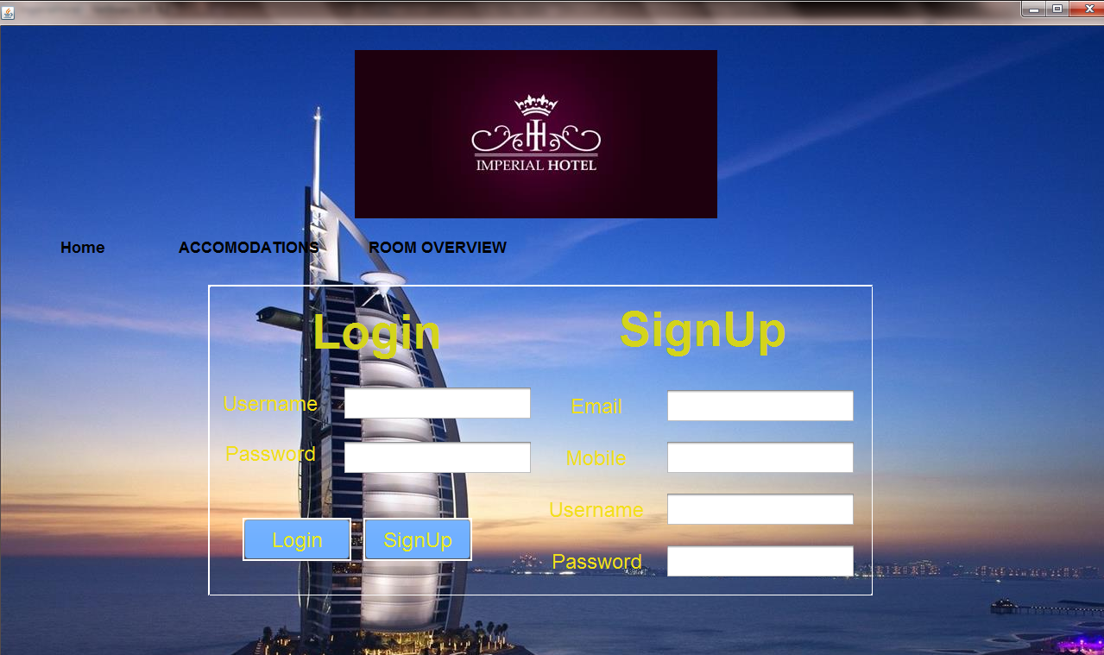

import java.sql.Connection;

import java.sql.DriverManager;

import java.sql.ResultSet;

import java.sql.Statement;

import javax.swing.JOptionPane;

/**

*

* @author Visu

*/

public class Login extends javax.swing.JFrame {

/**

* Creates new form Login

*/

public Login() {

initComponents();

jLabel3.setIcon(new javax.swing.ImageIcon(getClass().getResource("/Images/wallpaper.jpg")));

jLabel1.setIcon(new javax.swing.ImageIcon(getClass().getResource("/Images/logonew.jpg")));

}

public Login(String date, int rooms, int pricefinal) {

initComponents();

}

/**

* This method is called from within the constructor to initialize the form.

* WARNING: Do NOT modify this code. The content of this method is always

* regenerated by the Form Editor.

*/

@SuppressWarnings("unchecked")

// <editor-fold defaultstate="collapsed" desc="Generated Code">

private void initComponents() {

jPanel2 = new javax.swing.JPanel();

jLabel5 = new javax.swing.JLabel();

jLabel6 = new javax.swing.JLabel();

jLabel2 = new javax.swing.JLabel();

Login_btn = new javax.swing.JButton();

jLabel8 = new javax.swing.JLabel();

jLabel9 = new javax.swing.JLabel();

q = new javax.swing.JTextField();

jLabel10 = new javax.swing.JLabel();

jLabel11 = new javax.swing.JLabel();

e = new javax.swing.JTextField();

jLabel12 = new javax.swing.JLabel();

Login_btn1 = new javax.swing.JButton();

a = new javax.swing.JTextField();

w = new javax.swing.JTextField();

r = new javax.swing.JTextField();

b = new javax.swing.JPasswordField();

jLabel1 = new javax.swing.JLabel();

jPanel1 = new javax.swing.JPanel();

jButton4 = new javax.swing.JButton();

jButton1 = new javax.swing.JButton();

jButton2 = new javax.swing.JButton();

jLabel3 = new javax.swing.JLabel();

setDefaultCloseOperation(javax.swing.WindowConstants.EXIT_ON_CLOSE);

jPanel2.setBorder(new javax.swing.border.SoftBevelBorder(javax.swing.border.BevelBorder.LOWERED, java.awt.Color.white, java.awt.Color.white, java.awt.Color.white, java.awt.Color.white));

jPanel2.setOpaque(false);

jPanel2.setLayout(null);

jLabel5.setFont(new java.awt.Font("Chaparral Pro Light", 1, 55)); // NOI18N

jLabel5.setForeground(new java.awt.Color(212, 212, 27));

jLabel5.setHorizontalAlignment(javax.swing.SwingConstants.CENTER);

jLabel5.setText("Login");

jLabel5.setFocusable(false);

jLabel5.setHorizontalTextPosition(javax.swing.SwingConstants.CENTER);

jPanel2.add(jLabel5);

jLabel5.setBounds(12, 13, 366, 80);

jLabel6.setFont(new java.awt.Font("Chaparral Pro Light", 0, 24)); // NOI18N

jLabel6.setForeground(new java.awt.Color(242, 223, 27));

jLabel6.setHorizontalAlignment(javax.swing.SwingConstants.CENTER);

jLabel6.setText("Username");

jLabel6.setFocusable(false);

jLabel6.setHorizontalTextPosition(javax.swing.SwingConstants.CENTER);

jLabel6.setPreferredSize(new java.awt.Dimension(150, 40));

jPanel2.add(jLabel6);

jLabel6.setBounds(12, 117, 120, 40);

jLabel2.setBackground(new java.awt.Color(144, 213, 246));

jLabel2.setFont(new java.awt.Font("Chaparral Pro Light", 0, 24)); // NOI18N

jLabel2.setForeground(new java.awt.Color(242, 223, 27));

jLabel2.setHorizontalAlignment(javax.swing.SwingConstants.CENTER);

jLabel2.setText("Password");

jLabel2.setFocusable(false);

jLabel2.setHorizontalTextPosition(javax.swing.SwingConstants.CENTER);

jLabel2.setPreferredSize(new java.awt.Dimension(150, 40));

jPanel2.add(jLabel2);

jLabel2.setBounds(12, 175, 120, 40);

Login_btn.setBackground(new java.awt.Color(90, 159, 246));

Login_btn.setFont(new java.awt.Font("Chaparral Pro Light", 0, 24)); // NOI18N

Login_btn.setForeground(new java.awt.Color(236, 236, 30));

Login_btn.setText("Login");

Login_btn.setBorder(javax.swing.BorderFactory.createBevelBorder(javax.swing.border.BevelBorder.RAISED, java.awt.Color.white, java.awt.Color.white, java.awt.Color.white, java.awt.Color.white));

Login_btn.setCursor(new java.awt.Cursor(java.awt.Cursor.HAND_CURSOR));

Login_btn.setHorizontalTextPosition(javax.swing.SwingConstants.CENTER);

Login_btn.addActionListener(new java.awt.event.ActionListener() {

public void actionPerformed(java.awt.event.ActionEvent evt) {

Login_btnActionPerformed(evt);

}

});

jPanel2.add(Login_btn);

Login_btn.setBounds(40, 270, 126, 50);

jLabel8.setFont(new java.awt.Font("Chaparral Pro Light", 1, 55)); // NOI18N

jLabel8.setForeground(new java.awt.Color(212, 212, 27));

jLabel8.setHorizontalAlignment(javax.swing.SwingConstants.CENTER);

jLabel8.setText("SignUp");

jLabel8.setFocusable(false);

jLabel8.setHorizontalTextPosition(javax.swing.SwingConstants.CENTER);

jPanel2.add(jLabel8);

jLabel8.setBounds(390, 10, 366, 80);

jLabel9.setFont(new java.awt.Font("Chaparral Pro Light", 0, 24)); // NOI18N

jLabel9.setForeground(new java.awt.Color(242, 223, 27));

jLabel9.setHorizontalAlignment(javax.swing.SwingConstants.CENTER);

jLabel9.setText("Email");

jLabel9.setFocusable(false);

jLabel9.setHorizontalTextPosition(javax.swing.SwingConstants.CENTER);

jLabel9.setPreferredSize(new java.awt.Dimension(150, 40));

jPanel2.add(jLabel9);

jLabel9.setBounds(390, 120, 120, 40);

q.setFont(new java.awt.Font("Javanese Text", 0, 24)); // NOI18N

q.addActionListener(new java.awt.event.ActionListener() {

public void actionPerformed(java.awt.event.ActionEvent evt) {

qActionPerformed(evt);

}

});

jPanel2.add(q);

q.setBounds(530, 120, 220, 40);

jLabel10.setBackground(new java.awt.Color(144, 213, 246));

jLabel10.setFont(new java.awt.Font("Chaparral Pro Light", 0, 24)); // NOI18N

jLabel10.setForeground(new java.awt.Color(242, 223, 27));

jLabel10.setHorizontalAlignment(javax.swing.SwingConstants.CENTER);

jLabel10.setText("Mobile");

jLabel10.setFocusable(false);

jLabel10.setHorizontalTextPosition(javax.swing.SwingConstants.CENTER);

jLabel10.setPreferredSize(new java.awt.Dimension(150, 40));

jPanel2.add(jLabel10);

jLabel10.setBounds(390, 180, 120, 40);

jLabel11.setFont(new java.awt.Font("Chaparral Pro Light", 0, 24)); // NOI18N

jLabel11.setForeground(new java.awt.Color(242, 223, 27));

jLabel11.setHorizontalAlignment(javax.swing.SwingConstants.CENTER);

jLabel11.setText("Username");

jLabel11.setFocusable(false);

jLabel11.setHorizontalTextPosition(javax.swing.SwingConstants.CENTER);

jLabel11.setPreferredSize(new java.awt.Dimension(150, 40));

jPanel2.add(jLabel11);

jLabel11.setBounds(390, 240, 120, 40);

e.setFont(new java.awt.Font("Javanese Text", 0, 24)); // NOI18N

e.addActionListener(new java.awt.event.ActionListener() {

public void actionPerformed(java.awt.event.ActionEvent evt) {

eActionPerformed(evt);

}

});

jPanel2.add(e);

e.setBounds(530, 240, 220, 40);

jLabel12.setBackground(new java.awt.Color(144, 213, 246));

jLabel12.setFont(new java.awt.Font("Chaparral Pro Light", 0, 24)); // NOI18N

jLabel12.setForeground(new java.awt.Color(242, 223, 27));

jLabel12.setHorizontalAlignment(javax.swing.SwingConstants.CENTER);

jLabel12.setText("Password");

jLabel12.setFocusable(false);

jLabel12.setHorizontalTextPosition(javax.swing.SwingConstants.CENTER);

jLabel12.setPreferredSize(new java.awt.Dimension(150, 40));

jPanel2.add(jLabel12);

jLabel12.setBounds(390, 300, 120, 40);

Login_btn1.setBackground(new java.awt.Color(90, 159, 246));

Login_btn1.setFont(new java.awt.Font("Chaparral Pro Light", 0, 24)); // NOI18N

Login_btn1.setForeground(new java.awt.Color(236, 236, 30));

Login_btn1.setText("SignUp");

Login_btn1.setBorder(javax.swing.BorderFactory.createBevelBorder(javax.swing.border.BevelBorder.RAISED, java.awt.Color.white, java.awt.Color.white, java.awt.Color.white, java.awt.Color.white));

Login_btn1.setCursor(new java.awt.Cursor(java.awt.Cursor.HAND_CURSOR));

Login_btn1.setHorizontalTextPosition(javax.swing.SwingConstants.CENTER);

Login_btn1.addActionListener(new java.awt.event.ActionListener() {

public void actionPerformed(java.awt.event.ActionEvent evt) {

Login_btn1ActionPerformed(evt);

}

});

jPanel2.add(Login_btn1);

Login_btn1.setBounds(180, 270, 126, 50);

a.setFont(new java.awt.Font("Javanese Text", 0, 24)); // NOI18N

a.addActionListener(new java.awt.event.ActionListener() {

public void actionPerformed(java.awt.event.ActionEvent evt) {

aActionPerformed(evt);

}

});

jPanel2.add(a);

a.setBounds(146, 117, 230, 40);

w.setFont(new java.awt.Font("Javanese Text", 0, 24)); // NOI18N

w.addActionListener(new java.awt.event.ActionListener() {

public void actionPerformed(java.awt.event.ActionEvent evt) {

wActionPerformed(evt);

}

});

jPanel2.add(w);

w.setBounds(530, 180, 220, 40);

r.setFont(new java.awt.Font("Javanese Text", 0, 24)); // NOI18N

r.addActionListener(new java.awt.event.ActionListener() {

public void actionPerformed(java.awt.event.ActionEvent evt) {

rActionPerformed(evt);

}

});

jPanel2.add(r);

r.setBounds(530, 300, 220, 40);

b.setMinimumSize(new java.awt.Dimension(6, 38));

jPanel2.add(b);

b.setBounds(146, 180, 230, 40);

jLabel1.setHorizontalAlignment(javax.swing.SwingConstants.CENTER);

jPanel1.setOpaque(false);

jPanel1.setLayout(null);

jButton4.setFont(new java.awt.Font("Dialog", 1, 18)); // NOI18N

jButton4.setText("ACCOMODATIONS");

jButton4.setContentAreaFilled(false);

jButton4.setRequestFocusEnabled(false);

jButton4.addActionListener(new java.awt.event.ActionListener() {

public void actionPerformed(java.awt.event.ActionEvent evt) {

jButton4ActionPerformed(evt);

}

});

jPanel1.add(jButton4);

jButton4.setBounds(190, 0, 195, 33);

jButton1.setFont(new java.awt.Font("Dialog", 1, 18)); // NOI18N

jButton1.setText("ROOM OVERVIEW");

jButton1.setContentAreaFilled(false);

jButton1.setMaximumSize(new java.awt.Dimension(195, 33));

jButton1.setMinimumSize(new java.awt.Dimension(195, 33));

jButton1.addActionListener(new java.awt.event.ActionListener() {

public void actionPerformed(java.awt.event.ActionEvent evt) {

jButton1ActionPerformed(evt);

}

});

jPanel1.add(jButton1);

jButton1.setBounds(410, 0, 193, 33);

jButton2.setFont(new java.awt.Font("Dialog", 1, 18)); // NOI18N

jButton2.setText("Home");

jButton2.setContentAreaFilled(false);

jButton2.setMaximumSize(new java.awt.Dimension(195, 33));

jButton2.setMinimumSize(new java.awt.Dimension(195, 33));

jButton2.addActionListener(new java.awt.event.ActionListener() {

public void actionPerformed(java.awt.event.ActionEvent evt) {

jButton2ActionPerformed(evt);

}

});

jPanel1.add(jButton2);

jButton2.setBounds(30, 0, 131, 33);

jLabel3.setPreferredSize(new java.awt.Dimension(800, 500));

javax.swing.GroupLayout layout = new javax.swing.GroupLayout(getContentPane());

getContentPane().setLayout(layout);

layout.setHorizontalGroup(

layout.createParallelGroup(javax.swing.GroupLayout.Alignment.LEADING)

.addGap(0, 1310, Short.MAX_VALUE)

.addGroup(layout.createParallelGroup(javax.swing.GroupLayout.Alignment.LEADING)

.addGroup(layout.createSequentialGroup()

.addGap(0, 0, Short.MAX_VALUE)

.addGroup(layout.createParallelGroup(javax.swing.GroupLayout.Alignment.LEADING)

.addGroup(layout.createSequentialGroup()

.addGap(410, 410, 410)

.addComponent(jLabel1, javax.swing.GroupLayout.PREFERRED_SIZE, 420, javax.swing.GroupLayout.PREFERRED_SIZE))

.addComponent(jPanel1, javax.swing.GroupLayout.PREFERRED_SIZE, 720, javax.swing.GroupLayout.PREFERRED_SIZE)

.addGroup(layout.createSequentialGroup()

.addGap(240, 240, 240)

.addComponent(jPanel2, javax.swing.GroupLayout.PREFERRED_SIZE, 770, javax.swing.GroupLayout.PREFERRED_SIZE))

.addComponent(jLabel3, javax.swing.GroupLayout.PREFERRED_SIZE, 1310, javax.swing.GroupLayout.PREFERRED_SIZE))

.addGap(0, 0, Short.MAX_VALUE)))

);

layout.setVerticalGroup(

layout.createParallelGroup(javax.swing.GroupLayout.Alignment.LEADING)

.addGap(0, 750, Short.MAX_VALUE)

.addGroup(layout.createParallelGroup(javax.swing.GroupLayout.Alignment.LEADING)

.addGroup(layout.createSequentialGroup()

.addGap(0, 0, Short.MAX_VALUE)

.addGroup(layout.createParallelGroup(javax.swing.GroupLayout.Alignment.LEADING)

.addGroup(layout.createSequentialGroup()

.addGap(20, 20, 20)

.addComponent(jLabel1, javax.swing.GroupLayout.PREFERRED_SIZE, 210, javax.swing.GroupLayout.PREFERRED_SIZE)

.addGap(10, 10, 10)

.addComponent(jPanel1, javax.swing.GroupLayout.PREFERRED_SIZE, 40, javax.swing.GroupLayout.PREFERRED_SIZE)

.addGap(20, 20, 20)

.addComponent(jPanel2, javax.swing.GroupLayout.PREFERRED_SIZE, 360, javax.swing.GroupLayout.PREFERRED_SIZE))

.addComponent(jLabel3, javax.swing.GroupLayout.PREFERRED_SIZE, 750, javax.swing.GroupLayout.PREFERRED_SIZE))

.addGap(0, 0, Short.MAX_VALUE)))

);

pack();

}// </editor-fold>

private void Login_btnActionPerformed(java.awt.event.ActionEvent evt) {

String username = a.getText();

String password =b.getText();

String test=username;

try

{

Class.forName("java.sql.DriverManager");

Connection con = (Connection)

DriverManager.getConnection("jdbc:mysql://localhost:3306/imperial_hotel","root", "seal1234");

Statement stmt = (Statement) con.createStatement();

String query="SELECT username FROM login WHERE username='"+username+"'&& password='"+password+"' ;";

ResultSet rs=stmt.executeQuery(query);

if (rs.next())

{

String user = rs.getString("username");

if(user.equals(test))

{

JOptionPane.showMessageDialog(this,"Welcome user");

int SNO=0;

String getsno="SELECT Max(SNO) FROM booking;";

ResultSet rs1=stmt.executeQuery(getsno);

if (rs1.next())

{

int SNO1 = rs.getInt("SNO");

SNO=SNO1+1;

}

String query2="select ;";

try {

String Advance;

String BookingNo;

String ChargesDay;

String Noperson;

String query1="INSERT INTO Test booking('"+SNO+"','"+username+"','"+Noperson+"','"+BookingNo+"','"+RoomNo+"','"+ChargesDay+"','"+Advance,Total+"');";

stmt.executeUpdate(query1);

}

catch(Exception e)

{

JOptionPane.showMessageDialog (this, e.getMessage());

}

TotalBill a = new TotalBill(test,username);

a.setVisible(true);

this.setVisible(false);

}

}

else

JOptionPane.showMessageDialog(this,"Sorry No Id exists!Please SingUp");

}

catch (Exception e)

{

JOptionPane.showMessageDialog(this, e.getMessage());

}

}

private void qActionPerformed(java.awt.event.ActionEvent evt) {

// TODO add your handling code here:

}

private void eActionPerformed(java.awt.event.ActionEvent evt) {

// TODO add your handling code here:

}

private void Login_btn1ActionPerformed(java.awt.event.ActionEvent evt) {

String email = q.getText();

String mobile = w.getText();

String username = e.getText();

String password = r.getText();

try {

Class.forName("java.sql.DriverManager");

Connection con = (Connection)

DriverManager.getConnection

("jdbc:mysql://localhost:3306/imperial_hotel","root", "seal1234");

Statement stmt = (Statement) con.createStatement();

String query="INSERT INTO Login VALUES('"+username+"','"+email+"','"+mobile+"','"+password+"','"+null+"');";

stmt.executeUpdate(query);

}

catch(Exception e)

//this block is executed in case of an exception

{

//Display an error message in the dialog box for an exception

JOptionPane.showMessageDialog (this, e.getMessage());

}

q.setText("");

w.setText("");

e.setText("");

r.setText("");

a.setText(username);

}

private void aActionPerformed(java.awt.event.ActionEvent evt) {

// TODO add your handling code here:

}

private void wActionPerformed(java.awt.event.ActionEvent evt) {

// TODO add your handling code here:

}

private void rActionPerformed(java.awt.event.ActionEvent evt) {

// TODO add your handling code here:

}

private void jButton4ActionPerformed(java.awt.event.ActionEvent evt) {

Accommodations f = new Accommodations();

f.setVisible(true);

this.setVisible(false);

}

private void jButton1ActionPerformed(java.awt.event.ActionEvent evt) {

RoomOverview c = new RoomOverview();

c.setVisible(true);

this.setVisible(false); // TODO add your handling code here:

}

private void jButton2ActionPerformed(java.awt.event.ActionEvent evt) {

Home z = new Home();

z.setVisible(true);

this.setVisible(false);

}

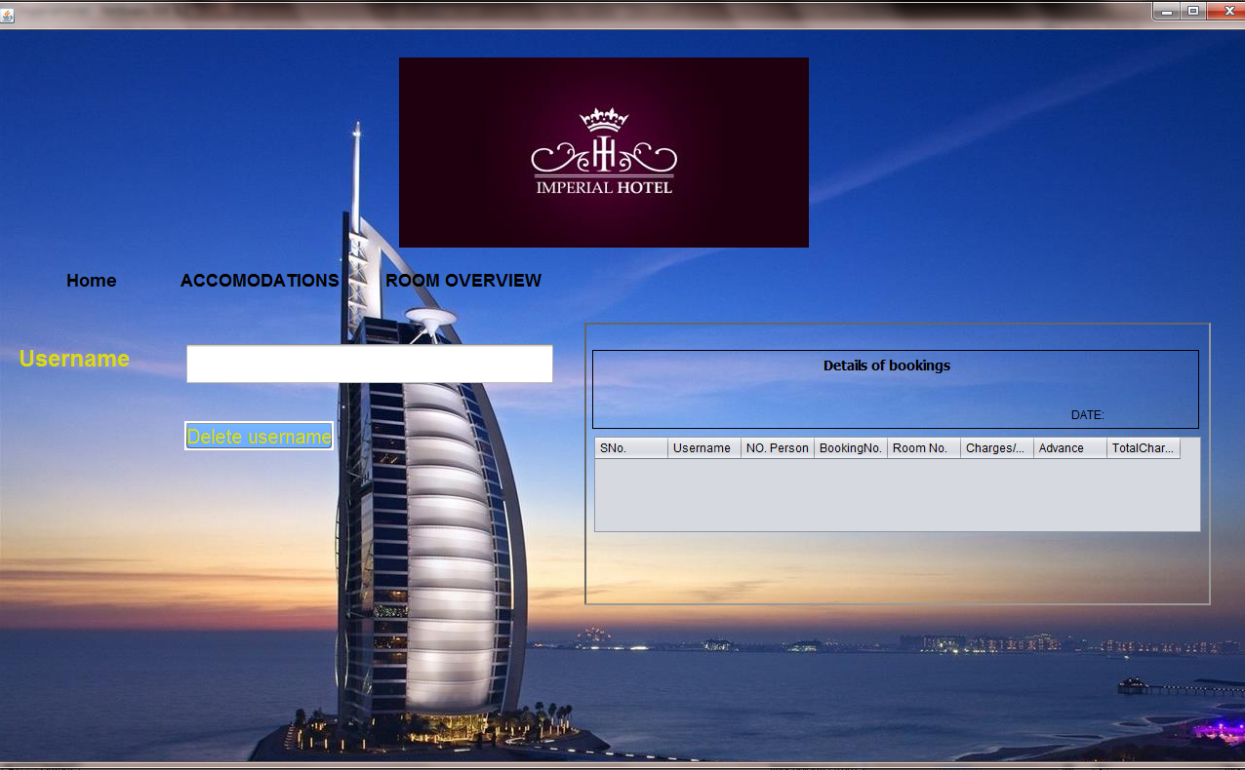

import java.sql.Connection;

import java.sql.DriverManager;

import java.sql.Statement;

import javax.swing.JOptionPane;

public AdminRights() {

initComponents();

jLabel3.setIcon(new javax.swing.ImageIcon(getClass().getResource("/Images/wallpaper.jpg")));

jLabel1.setIcon(new javax.swing.ImageIcon(getClass().getResource("/Images/logonew.jpg")));

} private void jButton4ActionPerformed(java.awt.event.ActionEvent evt) {

Accommodations a = new Accommodations();

a.setVisible(true);

this.setVisible(false);

}

private void jButton1ActionPerformed(java.awt.event.ActionEvent evt) {

RoomOverview a = new RoomOverview();

a.setVisible(true);

this.setVisible(false); // TODO add your handling code here:

}

private void jButton2ActionPerformed(java.awt.event.ActionEvent evt) {

Home a = new Home();

a.setVisible(true);

this.setVisible(false);

}

private void jButton5ActionPerformed(java.awt.event.ActionEvent evt) {

int Yes = JOptionPane.showConfirmDialog(this, "Are you sure You want to delete this username record", "massage", JOptionPane.YES_NO_OPTION ,JOptionPane.INFORMATION_MESSAGE);

if (Yes==0)

{

try {

Class.forName("java.sql.DriverManager");

Connection con = (Connection)

DriverManager.getConnection("jdbc:mysql://localhost:3306/imperial_hotel","root", "seal1234");

Statement stmt = (Statement) con.createStatement();

String query="delete from login where username='"+Remore_search.getText()+"'";

JOptionPane.showMessageDialog(this, "username deleted");

}

catch (Exception e) {

System.out.println(e);

}

}

}

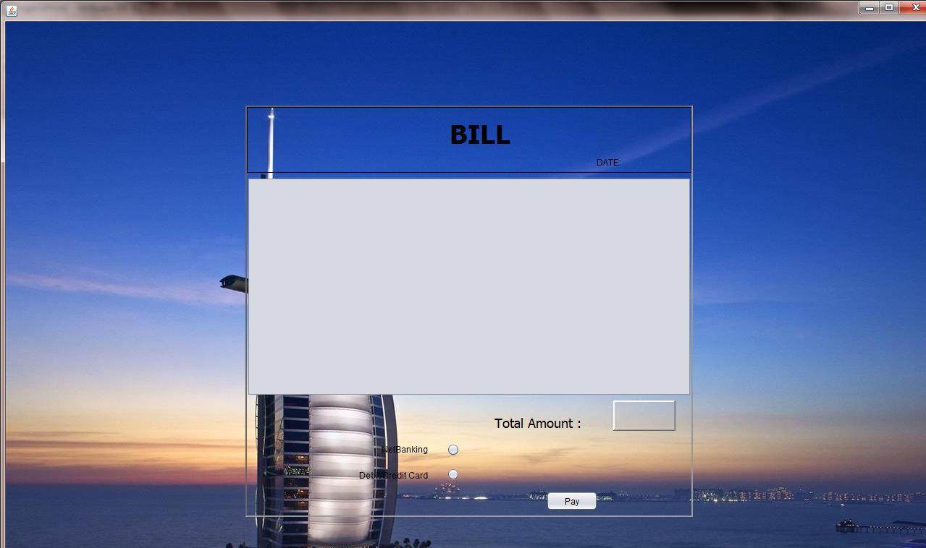

import imperial__hotel.Accommodations;

import imperial__hotel.Home;

import imperial__hotel.RoomOverview;

import java.sql.DriverManager;

import java.sql.ResultSet;

import java.sql.Statement;

import javax.swing.JOptionPane;

import javax.swing.table.DefaultTableModel;

/**

*

* @author student

*/

public class TotalBill extends javax.swing.JFrame {

/**

* Creates new form Bill

*/

public TotalBill( ) {

initComponents();

}

public TotalBill(String username, String test ) {

initComponents();

String id = username;

DefaultTableModel model = (DefaultTableModel) bill.getModel();

try

{

Class.forName("java.sql.DriverManager");

com.mysql.jdbc.Connection con = (com.mysql.jdbc.Connection)

DriverManager.getConnection("jdbc:mysql://localhost:3306/imperial_hotel","root", "seal1234");

Statement stmt = (Statement) con.createStatement();

String query= "select * from booking where username='"+id+"';";

ResultSet rs=stmt.executeQuery(query);

int i =0;

while(rs.next())

{

int SNO = 1;

SNO++;

String Noperson = rs.getString("rollno");

String BookingNo = rs.getString("name");

String RoomNo = rs.getString("class");

String ChargesDay = rs.getString("section");

String Advance = rs.getString("section");

String Total = rs.getString("section");

model.addRow(new Object[]{SNO,username,Noperson,BookingNo,RoomNo,ChargesDay,Advance,Total});

i++;

}

if(i <1)

{

JOptionPane.showMessageDialog(null, "No Record Found","Error",

JOptionPane.ERROR_MESSAGE);

}

if(i ==1)

{

System.out.println(i+" Record Found");

}

else

{

System.out.println(i+" Records Found");

}

}

catch(Exception ex)

{

JOptionPane.showMessageDialog(null, ex.getMessage(),"Error",

JOptionPane.ERROR_MESSAGE);

}

}

public TotalBill(String test) {

throw new UnsupportedOperationException("Not supported yet."); //To change body of generated methods, choose Tools | Templates.

}

/**

* This method is called from within the constructor to initialize the form.

* WARNING: Do NOT modify this code. The content of this method is always

* regenerated by the Form Editor.

*/

@SuppressWarnings("unchecked")

// <editor-fold defaultstate="collapsed" desc="Generated Code">

private void initComponents() {

jPanel3 = new javax.swing.JPanel();

jButton4 = new javax.swing.JButton();

jButton1 = new javax.swing.JButton();

jButton2 = new javax.swing.JButton();

jPanel2 = new javax.swing.JPanel();

jLabel5 = new javax.swing.JLabel();

TotalL = new javax.swing.JLabel();

jScrollPane1 = new javax.swing.JScrollPane();

bill = new javax.swing.JTable();

jPanel1 = new javax.swing.JPanel();

jLabel3 = new javax.swing.JLabel();

dateLBL = new javax.swing.JLabel();

jLabel2 = new javax.swing.JLabel();

jLabel6 = new javax.swing.JLabel();

jLabel4 = new javax.swing.JLabel();

setDefaultCloseOperation(javax.swing.WindowConstants.EXIT_ON_CLOSE);

getContentPane().setLayout(new org.netbeans.lib.awtextra.AbsoluteLayout());

jPanel3.setOpaque(false);

jPanel3.setLayout(null);

jButton4.setFont(new java.awt.Font("Dialog", 1, 18)); // NOI18N

jButton4.setText("ACCOMODATIONS");

jButton4.setContentAreaFilled(false);

jButton4.setRequestFocusEnabled(false);

jButton4.addActionListener(new java.awt.event.ActionListener() {

public void actionPerformed(java.awt.event.ActionEvent evt) {

jButton4ActionPerformed(evt);

}

});

jPanel3.add(jButton4);

jButton4.setBounds(190, 0, 195, 33);

jButton1.setFont(new java.awt.Font("Dialog", 1, 18)); // NOI18N

jButton1.setText("ROOM OVERVIEW");

jButton1.setContentAreaFilled(false);

jButton1.setMaximumSize(new java.awt.Dimension(195, 33));

jButton1.setMinimumSize(new java.awt.Dimension(195, 33));

jButton1.addActionListener(new java.awt.event.ActionListener() {

public void actionPerformed(java.awt.event.ActionEvent evt) {

jButton1ActionPerformed(evt);

}

});

jPanel3.add(jButton1);

jButton1.setBounds(410, 0, 193, 33);

jButton2.setFont(new java.awt.Font("Dialog", 1, 18)); // NOI18N

jButton2.setText("Home");

jButton2.setContentAreaFilled(false);

jButton2.setMaximumSize(new java.awt.Dimension(195, 33));

jButton2.setMinimumSize(new java.awt.Dimension(195, 33));

jButton2.addActionListener(new java.awt.event.ActionListener() {

public void actionPerformed(java.awt.event.ActionEvent evt) {

jButton2ActionPerformed(evt);

}

});

jPanel3.add(jButton2);

jButton2.setBounds(30, 0, 131, 33);

getContentPane().add(jPanel3, new org.netbeans.lib.awtextra.AbsoluteConstraints(0, 240, 720, 40));

jPanel2.setBorder(javax.swing.BorderFactory.createBevelBorder(javax.swing.border.BevelBorder.RAISED, new java.awt.Color(102, 102, 102), new java.awt.Color(102, 102, 102), new java.awt.Color(153, 153, 153), new java.awt.Color(153, 153, 153)));

jPanel2.setOpaque(false);

jLabel5.setFont(new java.awt.Font("Tahoma", 0, 18)); // NOI18N

jLabel5.setForeground(new java.awt.Color(255, 102, 102));

jLabel5.setText("Total Amount : ");

TotalL.setFont(new java.awt.Font("Tahoma", 0, 18)); // NOI18N

TotalL.setBorder(javax.swing.BorderFactory.createBevelBorder(javax.swing.border.BevelBorder.RAISED));

bill.setModel(new javax.swing.table.DefaultTableModel(

new Object [][] {

},

new String [] {

"SNo.", "Username", "NO. Person", "BookingNo.", "Room No.", "Charges/Day", "Advance", "TotalCharges"

}

) {

boolean[] canEdit = new boolean [] {

false, false, false, false, false, false, false, false

};

public boolean isCellEditable(int rowIndex, int columnIndex) {

return canEdit [columnIndex];

}

});

bill.setAutoResizeMode(javax.swing.JTable.AUTO_RESIZE_OFF);

bill.setOpaque(false);

bill.setRowHeight(25);

jScrollPane1.setViewportView(bill);

jPanel1.setBorder(javax.swing.BorderFactory.createLineBorder(new java.awt.Color(0, 0, 0)));

jPanel1.setOpaque(false);

jLabel3.setText("DATE:");

jLabel2.setFont(new java.awt.Font("Tahoma", 1, 14)); // NOI18N

jLabel2.setForeground(new java.awt.Color(255, 255, 51));

jLabel2.setText("BILL");

javax.swing.GroupLayout jPanel1Layout = new javax.swing.GroupLayout(jPanel1);

jPanel1.setLayout(jPanel1Layout);

jPanel1Layout.setHorizontalGroup(

jPanel1Layout.createParallelGroup(javax.swing.GroupLayout.Alignment.LEADING)

.addGroup(javax.swing.GroupLayout.Alignment.TRAILING, jPanel1Layout.createSequentialGroup()

.addContainerGap(325, Short.MAX_VALUE)

.addGroup(jPanel1Layout.createParallelGroup(javax.swing.GroupLayout.Alignment.LEADING)

.addGroup(javax.swing.GroupLayout.Alignment.TRAILING, jPanel1Layout.createSequentialGroup()

.addComponent(jLabel3)

.addGap(18, 18, 18)

.addComponent(dateLBL, javax.swing.GroupLayout.PREFERRED_SIZE, 72, javax.swing.GroupLayout.PREFERRED_SIZE)

.addContainerGap())

.addGroup(javax.swing.GroupLayout.Alignment.TRAILING, jPanel1Layout.createSequentialGroup()

.addComponent(jLabel2)

.addGap(276, 276, 276))))

);

jPanel1Layout.setVerticalGroup(

jPanel1Layout.createParallelGroup(javax.swing.GroupLayout.Alignment.LEADING)

.addGroup(javax.swing.GroupLayout.Alignment.TRAILING, jPanel1Layout.createSequentialGroup()

.addGap(39, 39, 39)

.addComponent(jLabel2)

.addPreferredGap(javax.swing.LayoutStyle.ComponentPlacement.RELATED, javax.swing.GroupLayout.DEFAULT_SIZE, Short.MAX_VALUE)

.addGroup(jPanel1Layout.createParallelGroup(javax.swing.GroupLayout.Alignment.LEADING)

.addComponent(dateLBL, javax.swing.GroupLayout.PREFERRED_SIZE, 16, javax.swing.GroupLayout.PREFERRED_SIZE)

.addComponent(jLabel3))

.addContainerGap())

);

javax.swing.GroupLayout jPanel2Layout = new javax.swing.GroupLayout(jPanel2);

jPanel2.setLayout(jPanel2Layout);

jPanel2Layout.setHorizontalGroup(

jPanel2Layout.createParallelGroup(javax.swing.GroupLayout.Alignment.LEADING)

.addGroup(jPanel2Layout.createSequentialGroup()

.addContainerGap()

.addGroup(jPanel2Layout.createParallelGroup(javax.swing.GroupLayout.Alignment.LEADING)

.addGroup(jPanel2Layout.createSequentialGroup()

.addComponent(jScrollPane1, javax.swing.GroupLayout.DEFAULT_SIZE, 645, Short.MAX_VALUE)

.addGap(1, 1, 1))

.addGroup(javax.swing.GroupLayout.Alignment.TRAILING, jPanel2Layout.createSequentialGroup()

.addComponent(jLabel5)

.addGap(43, 43, 43)

.addComponent(TotalL, javax.swing.GroupLayout.PREFERRED_SIZE, 86, javax.swing.GroupLayout.PREFERRED_SIZE)

.addContainerGap())

.addGroup(javax.swing.GroupLayout.Alignment.TRAILING, jPanel2Layout.createSequentialGroup()

.addComponent(jPanel1, javax.swing.GroupLayout.DEFAULT_SIZE, javax.swing.GroupLayout.DEFAULT_SIZE, Short.MAX_VALUE)

.addGap(10, 10, 10))))

);

jPanel2Layout.setVerticalGroup(

jPanel2Layout.createParallelGroup(javax.swing.GroupLayout.Alignment.LEADING)

.addGroup(javax.swing.GroupLayout.Alignment.TRAILING, jPanel2Layout.createSequentialGroup()

.addGap(26, 26, 26)

.addComponent(jPanel1, javax.swing.GroupLayout.PREFERRED_SIZE, javax.swing.GroupLayout.DEFAULT_SIZE, javax.swing.GroupLayout.PREFERRED_SIZE)

.addPreferredGap(javax.swing.LayoutStyle.ComponentPlacement.RELATED)

.addComponent(jScrollPane1, javax.swing.GroupLayout.DEFAULT_SIZE, 182, Short.MAX_VALUE)

.addGroup(jPanel2Layout.createParallelGroup(javax.swing.GroupLayout.Alignment.LEADING, false)

.addGroup(jPanel2Layout.createSequentialGroup()

.addGap(18, 18, 18)

.addComponent(TotalL, javax.swing.GroupLayout.PREFERRED_SIZE, 42, javax.swing.GroupLayout.PREFERRED_SIZE)

.addContainerGap())

.addGroup(javax.swing.GroupLayout.Alignment.TRAILING, jPanel2Layout.createSequentialGroup()

.addPreferredGap(javax.swing.LayoutStyle.ComponentPlacement.RELATED, javax.swing.GroupLayout.DEFAULT_SIZE, Short.MAX_VALUE)

.addComponent(jLabel5)

.addGap(19, 19, 19))))

);

getContentPane().add(jPanel2, new org.netbeans.lib.awtextra.AbsoluteConstraints(140, 330, 660, 380));

jLabel6.setHorizontalAlignment(javax.swing.SwingConstants.CENTER);

jLabel6.setIcon(new javax.swing.ImageIcon(getClass().getResource("/images/logonew.jpg"))); // NOI18N

getContentPane().add(jLabel6, new org.netbeans.lib.awtextra.AbsoluteConstraints(410, 20, 420, 210));

jLabel4.setIcon(new javax.swing.ImageIcon(getClass().getResource("/images/Wallpaper.jpg"))); // NOI18N

jLabel4.setPreferredSize(new java.awt.Dimension(800, 500));

getContentPane().add(jLabel4, new org.netbeans.lib.awtextra.AbsoluteConstraints(0, 0, 1310, 750));

pack();

}// </editor-fold>

private void jButton4ActionPerformed(java.awt.event.ActionEvent evt) {

Accommodations f = new Accommodations();

f.setVisible(true);

this.setVisible(false);

}

private void jButton1ActionPerformed(java.awt.event.ActionEvent evt) {

RoomOverview c = new RoomOverview();

c.setVisible(true);

this.setVisible(false); // TODO add your handling code here:

}

private void jButton2ActionPerformed(java.awt.event.ActionEvent evt) {

Home z = new Home();

z.setVisible(true);

this.setVisible(false); }